A Summer Industry Internship –ll Project Report on

**“ONLINE NEWS PORTAL SYSTEM”**

Submitted to

The Department of Computer Science and Engineering In partial fulfillment of the academic requirements of Jawaharlal Nehru Technological University For

The award of the degree of

Bachelor of Technology

in

Computer Science and Engineering

(2018 – 2022)

By

Ch.Udhay 18311A05R4

N.Satish Kumar 18311A05V2



Sreenidhi Institute of Science and Technology

Yamnampet, Ghatkesar, R.R. District, Hyderabad - 501301

Affiliated to

Jawaharlal Nehru Technology University

Hyderabad - 500085

Department of Computer Science and Engineering

Sreenidhi Institute of Science and Technology

**CERTIFICATE**

This is to certify that this Summer Industry Internship –I Project report on “

**ONLINE NEWS PORTAL SYSTEM** ”, submitted by **CH.UDHAY**

**(18311A05R4), N.SATISH KUMAR (18311A05V2)** in the year 2021 in partial fulfillment of the academic requirements of Jawaharlal Nehru Technological University for the award of the degree of Bachelor of Technology in Computer Science and Engineering, is a bonafide work that has been carried out by them as part of their **Mini Project** , under our guidance. This report has not been submitted to any other institute or university for the award of any degree.

Ms.N.Shivani

Assistant Professor

Department of CSE

**Project Coordinator**

Dr. Aruna Varanasi

Head, Department of CSE

External Examiner

Date:-

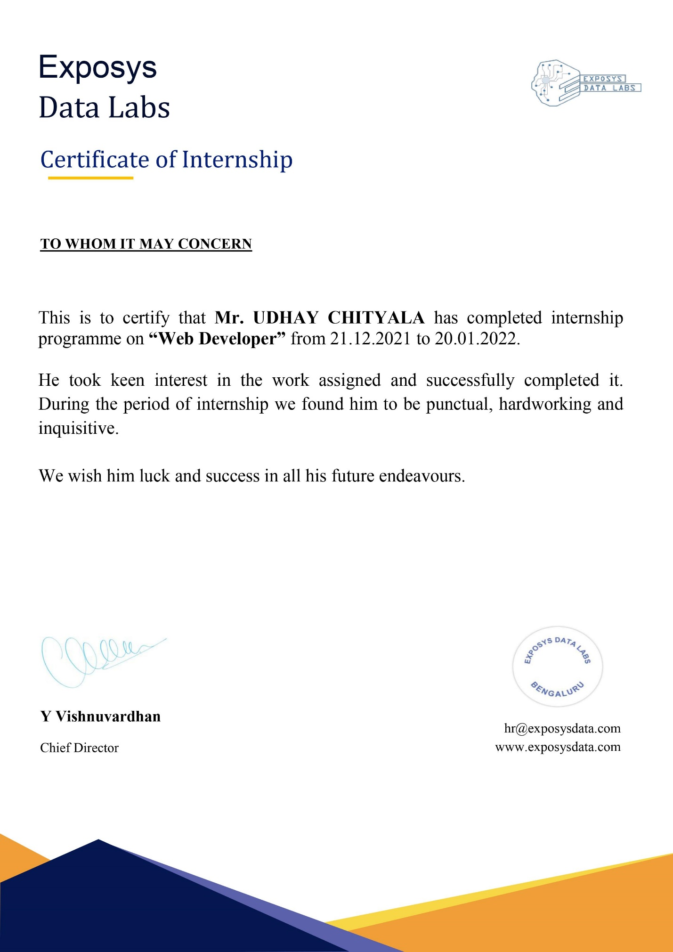



**DECLARATION**

We Ch,Udhay, N.Satish Kumar**,** student of **SREENIDHI INSTITUTE OF**

**SCIENCE AND TECHNOLOGY, YAMNAMPET, GHATKESAR,** studying IVrd year Istsemester, **COMPUTER SCIENCE AND ENGINEERING** solemnly declare that the Summer Industry Internship–Iproject work, titled **“ONLINE NEWS PORTAL SYSTEM”** is submitted to **SREENIDHI** **INSTITUTE OF SCIENCE AND TECHNOLOGY** for partialfulfillment for the award of degree of Bachelor of technology in **COMPUTER** **SCIENCE AND ENGINEERING**.

It is declared to the best of our knowledge that the work reported does not form part of any dissertation submitted to any other University or Institute for award of any degree

**ACKNOWLEDGEMENT**

I would like to express my gratitude to all the people behind the screen who helped me to transform an idea into a real application.

I would like to express my heart-felt gratitude to my parents without whom I would not have been privileged to achieve and fulfill my dreams. I am grateful to our principal, **Dr. T. Ch. Siva** **Reddy,** who most ably run the institution and has had the major hand in enabling me to do myproject.

I profoundly thank Dr. **ARUNA VARANASI**, Head of the Department of Computer Science & Engineering who has been an excellent guide and also a great source of inspiration to my work. I would like to thank my internal guide Mr.R.Arun Kumar for his technical guidance, constant encouragement and support in carrying out my project at college.

The satisfaction and euphoria that accompany the successful completion of the task would be great but incomplete without the mention of the people who made it possible with their constant guidance and encouragement crowns all the efforts with success. In this context, I would like thank all the other staff members, both teaching and non-teaching, who have extended their timely help and eased my task.

**CH.UDHAY**

**18311A05R4**

**N.SATISH KUMAR**

**18311A05V2**

**Abstract**

The purpose of Online News Portal is to automate the existing manual system by the help of computerized equipments and full-fledged computer software, fulfilling their requirements, so that their valuable data/information can be stored for a longer period with easy accessing and manipulation of the same. The required software and hardware are easily available and easy to work with.

Online News Portal, as described above, can lead to error free, secure, reliable and fast management system. It can assist the user to concentrate on their other activities rather to concentrate on the record keeping. Thus it will help organization in better utilization of resources. The organization can maintain computerized records without redundant entries. That means that one need not be distracted by information that is not relevant, while being able to reach the information.

The aim is to automate its existing manual system by the help of computerized equipments and full-fledged computer software, fulfilling their requirements, so that their valuable data/information can be stored for a longer period with easy accessing and manipulation of the same. Basically the project describes how to manage for good performance and better services for the clients.

|  |  |  |
| --- | --- | --- |
|  | **INDEX** |  |
| **1. INTRODUCTION** | | 1 |
| 1.1 scope | | 1 |
| 1.2 Existing System | | 2 |
| 1.3 Proposed System | | 2 |
| **2. SYSTEM ANALYSIS** | | 3 |
| 2.1 | Functional Requirement | 3 |
| 2.2 | Performance Requirements | 4 |
| 2.3 | Software Requirements | 4 |
| 2.4 | Hardware Requirements | 4 |

|  |  |  |  |
| --- | --- | --- | --- |
| **3.SYSTEM DESIGN** | | | 5 |
| 3.1 | Architecture Design | | 5 |
| 3.2 | Technology Layer | | 6 |
| 3.3 UML Diagrams | | | 7 |
|  | 3.3.1 | Use Case Diagrams | 7 |
|  | 3.3.2 | Class Diagrams | 10 |
|  |  |  |  |
|  | 3.3.3 | Activity Diagrams | 11 |
| **4. SYSTEM IMPLEMENTATION** | | | **12** |

|  |  |
| --- | --- |
| 4.1 Implementation code | 15 |
| **5. OUTPUT SCREENS** | 18 |
| **6. CONCLUSIONS AND FUTURE SCOPE** | 24 |
| **7. BIBLIOGRAPHY** | 24 |
| Appendix-A:MySQL | 25 |
| Appendix-B:Unified Modeling Language | 27 |

**1. INTRODUCTION**

Now-a-days we live in age of Information Communication and Technology . We can’t think a single moment without technology.From morning to night, we need help of the technology. This is the revolutionary time of computer technology. Most of the works depends on web application. For this reason, anytime, anywhere, anyone can access a website by internet at low cost and we can find our expectable and most update information from website. At present information is one the most valuable resource of the current world. We have developed our project so that we can aware the people.

**1.1 Scope**

It may help collecting perfect management in details. In a very short time, the collection will be obvious, simple and sensible. It will help a person to know the management of passed year perfectly and vividly. It also helps in current all works relative to Online News Portal. It will be also reduced the cost of collecting the management & collection procedure will go on smoothly.

Our project aims at Business process automation, i.e. we have tried to computerize various processes of Online News Portal.

• In computer system the person has to fill the various forms & number of copies of the forms can be easily generated at a time.

• In computer system, it is not necessary to create the manifest but we can directly print it, which saves our time.

• To assist the staff in capturing the effort spent on their respective working areas.

• To utilize resources in an efficient manner by increasing their productivity through automation.

• The system generates types of information that can be used for various purposes.

• It satisfy the user requirement

• Be easy to understand by the user and operator & Be easy to operate • Have a good user interface & Be expandable

• Delivered on schedule within the budget

1

**1.2 Existing System**

* In the present system a customer has to approach various agencies to find the news portal to read news online.
* This often requires a lot of time and effort.
* A customer may not get the desired information from these offices and often the customer may be misguided.
* It is tedious for a customer to plan a particular News and have it executed properly.

**1.3 Proposed System**

* The proposed system is a web based application and maintains a centralized repository of all related information.
* The system allows one to easily access the relevant information and make necessary online news arrangements.
* Users can read news online want to visit and read the specific they want according to their interests.

2

**2. SYSTEM ANALYSIS**

**2.1FUNCTIONAL REQUIREMENTS:**

**Number of Modules**

* After careful analysis the system has been identified to have the following modules:

**1**. Administrator module

1. Sub-admin module
2. User module

**1.ADMINISTRATOR MODULE:**

This module provides administrator related functionality. Administrator manages all information and has access rights to add, delete, edit and view the data.

**Admin Dashboard:** In this section admin can view, listed categories & sub categories, total published news & trashed news.

**Sub-admin:** In this section, admin can add/edit/delete sub-admin.  
**Category :** In this section admin can add/update/delete the category. Admin can also restore

deleted category.

**Sub- Category :** In this section admin can add/update/delete the Subcategory. Admin can

also restore deleted Subcategory**.**

**2.SUB-ADMIN MODULE**  
Sub-Admin and Admin features are the same except Sub-Admin creation. Sub-Admin can’t create the Sub-Admins.

**3.USER MODULE:**

* Anyone can read the news and also search for particular news. The reader can leave comments on the particular news.

**2.2 Performance Requirements**

Performance is measured in terms of the output provided by the application. Requirement specification plays an important part in the analysis of a system. Only when the requirement specifications are properly given, it is possible to design a system, which will fit into required environment. It rests largely with the users of the existing system to give the requirement specifications because they are the people who finally use the system. This is because the requirements have to be known during the initial stages so that the system can be designed according to those requirements. It is very difficult to change the system once it has been designed and on the other hand designing a system, which does not cater to the requirements of the user, is of no use.

The requirement specification for any system can be broadly stated as given below:

* The system should be able to interface with the existing system
* The system should be accurate
* The system should be better than the existing system

The existing system is completely dependent on the user to perform all the duties.

**2.3 Software Requirements**:

|  |  |
| --- | --- |
| ◆ Operating System – | Windows10 |
| ◆ Language used– | php |
| ◆ Database: | mysql |
| ◆ Software: | xampp |
| ◆ Web browser: | Google Chrome |

**2.4 Hardware Requirements**:

◆

RAM –

8GB

◆

Processor –

intel i5

4

**3.SYSTEM DESIGN**

Systems design is the process of defining the architecture, components, modules, interfaces, and [data](http://en.wikipedia.org/wiki/Data) for a [system](http://en.wikipedia.org/wiki/System) to satisfy specified [requirements.](http://en.wikipedia.org/wiki/Requirement) One could see it as the application of [systems theory](http://en.wikipedia.org/wiki/Systems_theory) to [product](http://en.wikipedia.org/wiki/Product_development) [development.](http://en.wikipedia.org/wiki/Product_development) [Object-oriented analysis and design](http://en.wikipedia.org/wiki/Object-oriented_analysis_and_design) methods are becoming the most widely used methods for computer systems design.

**3.1 Architectural Design**

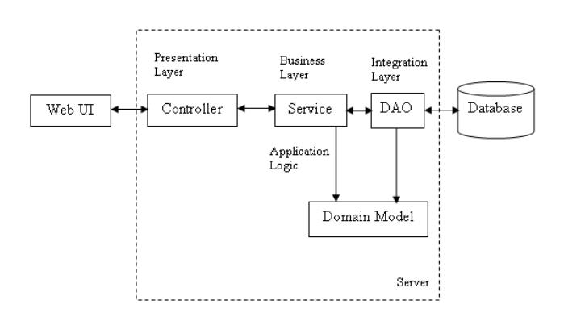

The whole software design can be divided mainly into 3 parts - WebUI, a middleware layer and a persistence layer. This project is developed for a tourism manager where he is able to add new posts, update/delete the news. It also has a search module where the assistant can search the news based on their category.

5

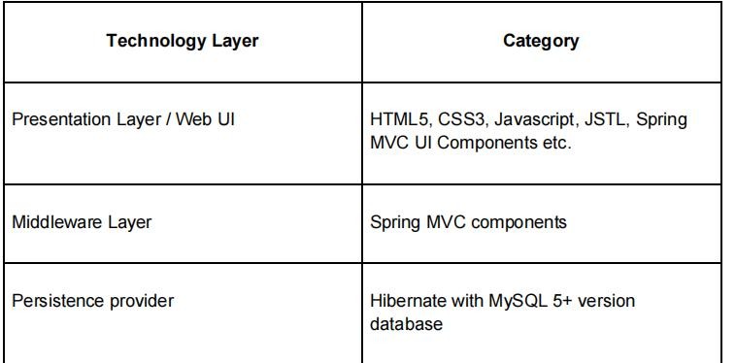

* The data in the system has to be stored and retrieved from database. Designing the

database is part of system design. Data elements and data structures to be stored have been identified at analysis stage. They are structured and put together to design the data storage and retrieval system.

* A database is a collection of interrelated data stored with minimum redundancy to serve many users quickly and efficiently. The general objective is to make database access easy, quick, inexpensive and flexible for the user. Relationships are established between the data items and unnecessary data items are removed. Normalization is done to get an internal consistency of data and to have minimum redundancy and maximum stability. This ensures minimizing data storage required, minimizing chances of data inconsistencies and optimizing for updates. The MySQL database has been chosen for developing the relevant databases.

Fig 3.1 Architectural Design

6

**3.3 UML Diagrams**

A UML diagram is a diagram based on the UML (Unified Modeling Language) with the purpose

of visually representing a system along with its main actors, roles, actions, artifacts or classes, in order to better understand, alter, maintain, or document information about the system.UML is an acronym that stands for Unified Modeling Language. Simply put, UML is a modern approach to modeling and documenting software.

It is based on diagrammatic representations of software components. As the old proverb says: “a picture is worth a thousand words”. By using visual representations, we are able to better understand possible flaws or errors in software or business processes.

Mainly, UML has been used as a general-purpose modeling language in the field of software engineering. For example, activity diagrams, a type of UML diagram, can be used as a replacement for flowcharts. They provide both a more standardized way of modeling workflows as well as a wider range of features to improve readability and efficiency.

UML Diagrams for our application are as follows:

**3.3.1 Use Case Diagrams**

A use case diagram is a graphical depiction of a user's possible interactions with a system. A use case diagram shows various use cases and different types of users the system has and will often be accompanied by other types of diagrams as well. The use cases are represented by either circles or ellipses. The actors are often shown as stick figures.

7

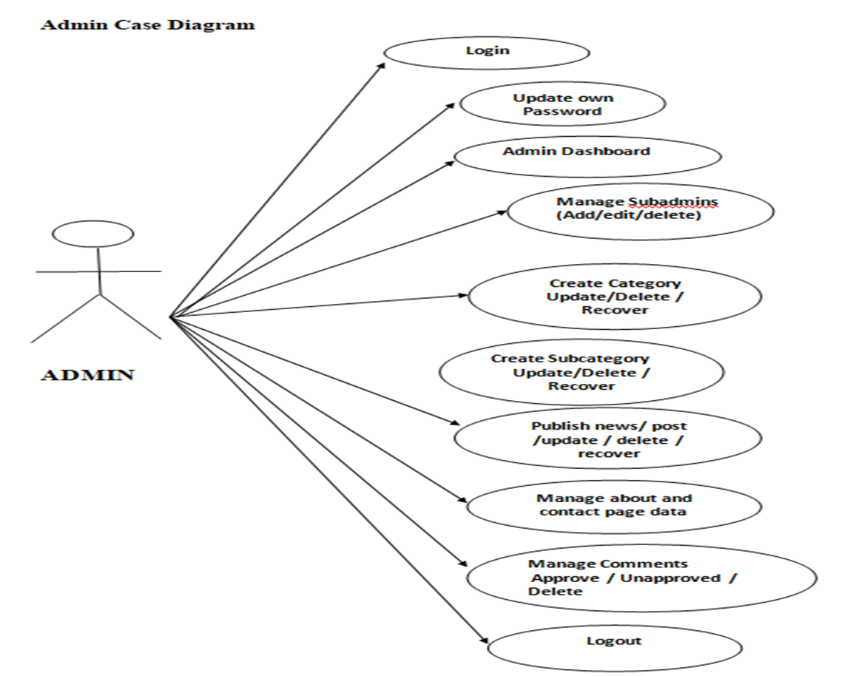

3.2 Usecase Diagram for Administrator’s Module

This UseCase Diagram depicts the functionality of Administrator. Administrator has two functionalities namely Manage Requests and Change Passwords.Here actor is Administrator and manage requests and change passwords and other features also are his use cases.Usecase manage requests means administrator can accept/reject the pending requests by customers. Usecase change password means that administrator has authority to change the password of his own account .

8

**User**

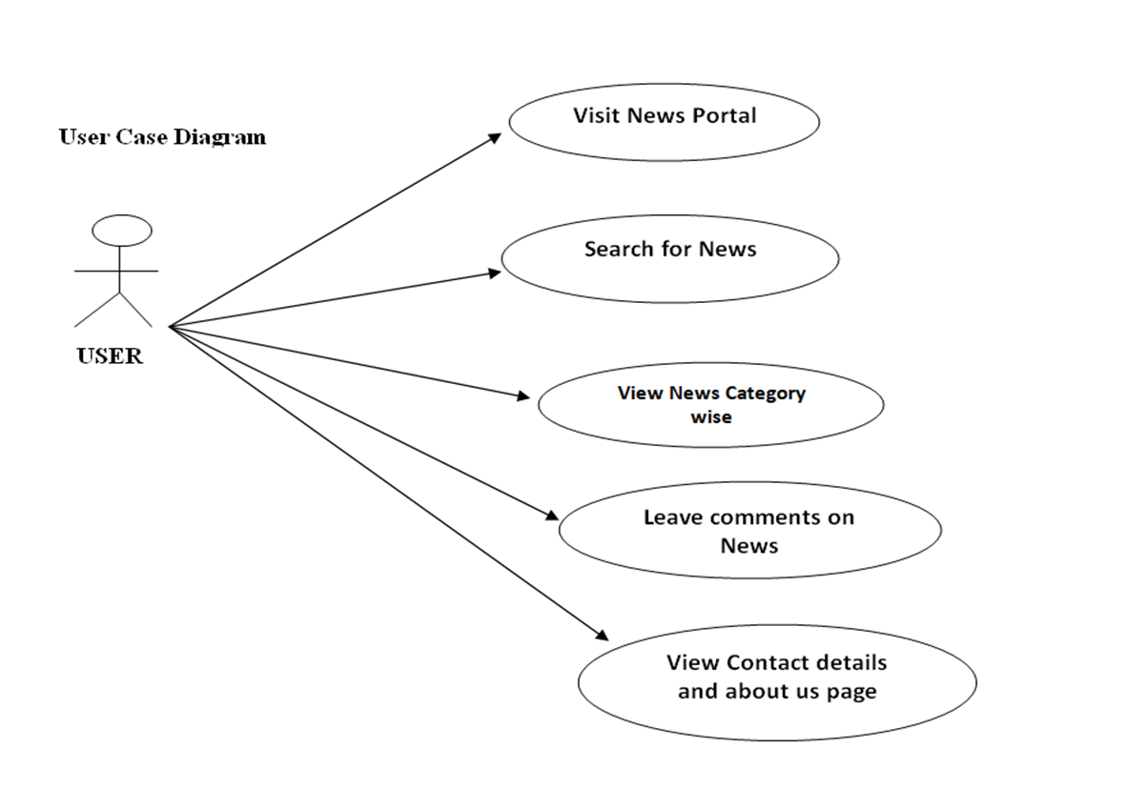

**3.3 Usecase Diagram for User’s Module**

This UseCase Diagram depicts the functionality of User. User has functionalities namely visits News Portal,Search for News, view News Category, commenting on news, manage account etc .Here actor is User and his usecases are Login,visit News,etc. Here actor ie. User can add event to database ,view posts, and he can also raise issues regarding the posts, so these are included his usecases..

9

**3.3.2 Class Diagram**

Class diagram shows a collection of classes, interfaces, associations, collaborations, and constraints. It is also known as a structural diagram.Class diagram is a static diagram.It represents the static view of an application class diagram is not only used for visualizing, describing, and documenting different aspects of system butals o for constructing executable code of the software application.Class diagram describes the attributes and operations of a class and also the Constraints imposed on the system.The class diagrams are widely used in the modeling of object oriented systems because they are the only UML diagrams which can be mapped directly with object-oriented languages.

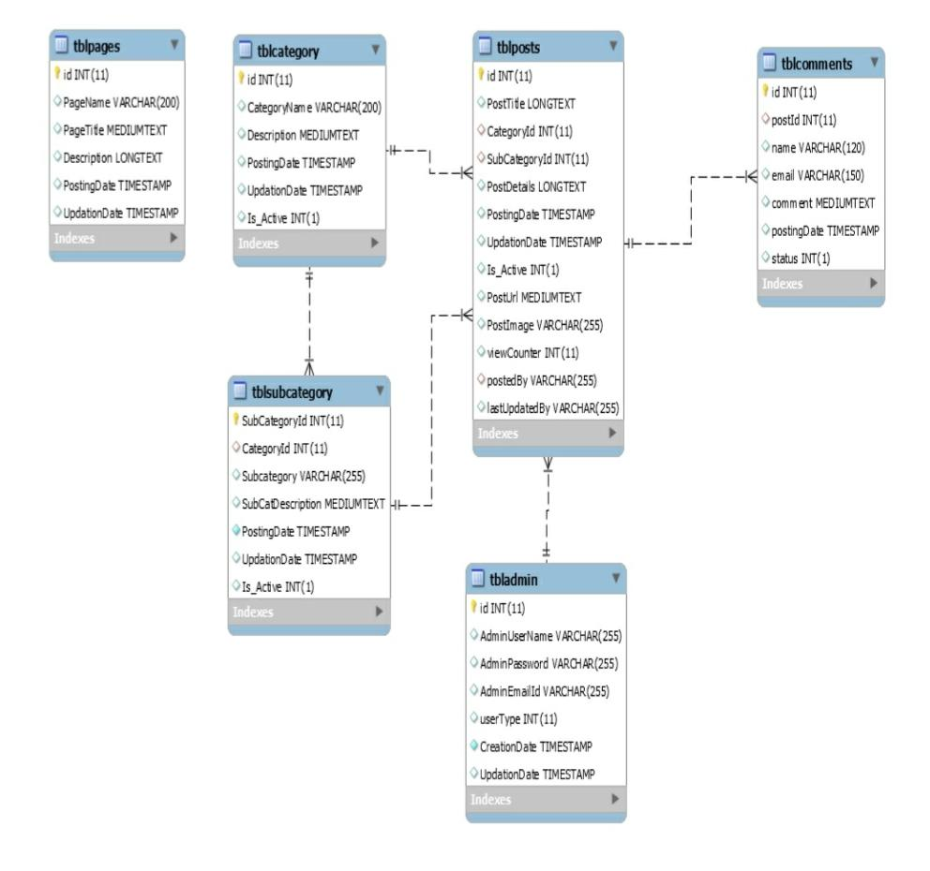

Fig 3.5 Class Diagram for Online News Portal system

10

**3.3.4 Activity Diagram**

An Activity in the activity diagram is also known as Activity state. It is used to represent the invocation of operation, a step in an entire business process. Swimlane is a way in which the performed activities can be grouped by the same actor on an Activity diagram.Activity diagram is another important diagram in UML to describe the dynamic aspects of the system.Activity diagram is basically a flow chart to represent the flow from one activity to another activity.The activity can be

described as an operation of the system.The control flow is drawn from one operation to another.This flow can be sequential,branched,or concurrent.Activity diagrams deal with all type of flow control by using Different elements such as fork,join,etc

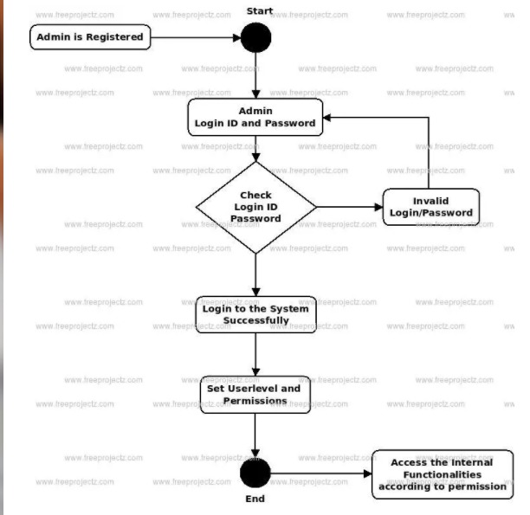

11

**4.SYSTEM IMPLEMENTATION**

The implementation stage of any project is a true display of the defining moments that make a project a success or a failure. The implementation stage is defined as the system or system modifications being installed and made operational in a production environment. The phase is initiated after the system has been tested and accepted by the user. This phase continues until the system is operating in production in accordance with the defined user requirements.

**Database Design**

The data in the system has to be stored and retrieved from database. Designing the database is part of system design. Data elements and data structures to be stored have been identified at analysis stage. They are structured and put together to design the data storage and retrieval system.

A database is a collection of interrelated data stored with minimum redundancy to serve many users quickly and efficiently. The general objective is to make database access easy, quick, inexpensive and flexible for the user. Relationships are established between the data items and unnecessary data items are removed. Normalization is done to get an internal consistency of data and to have minimum redundancy and maximum stability. This ensures minimizing data storage required, minimizing chances of data inconsistencies and optimizing for updates. The MySQL database has been chosen for developing the relevant databases.

**Database tables and Structure**

**Admin Table:** This table store the admin login details.

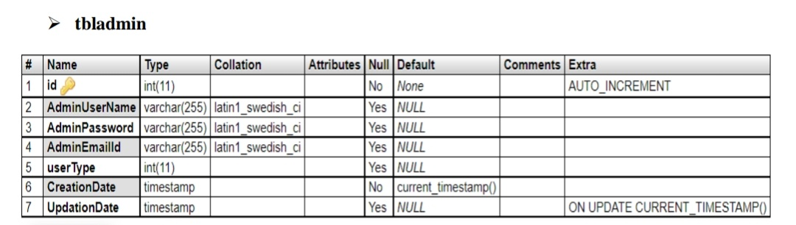

12

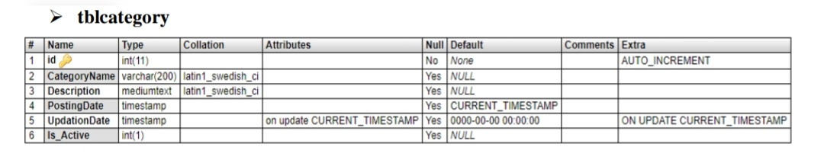

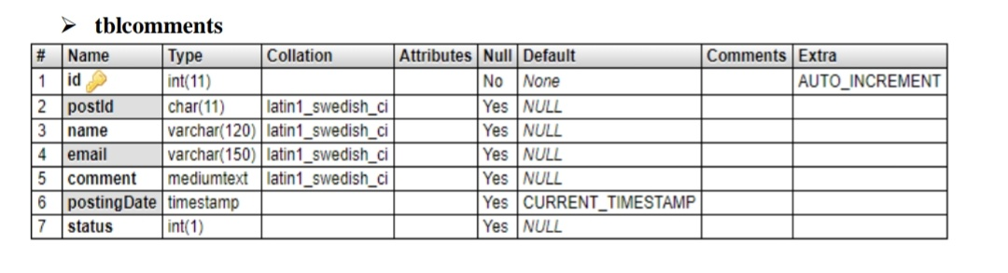

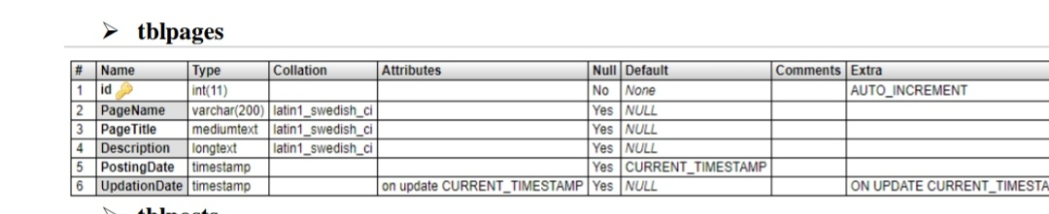

13

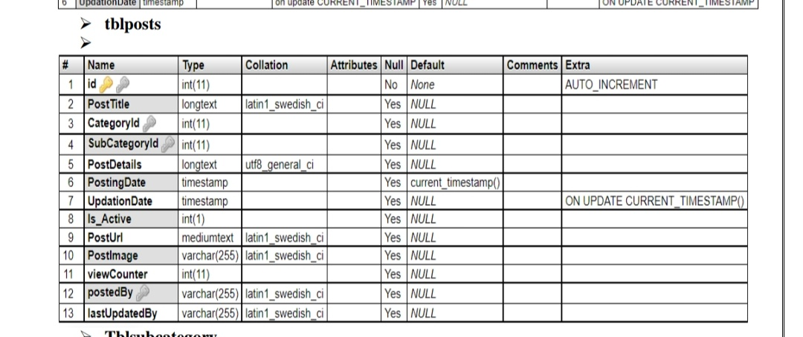

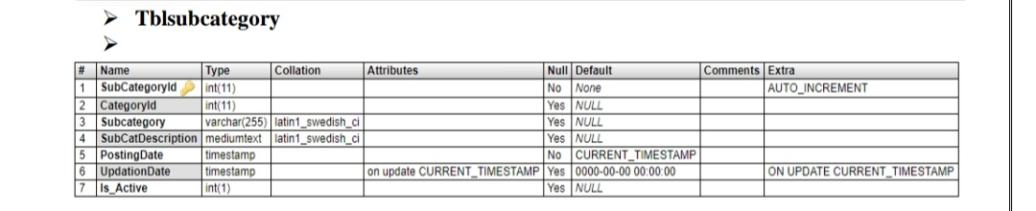

**Implimentation steps:**

* Create a folder(Online-News-Portal-System-using-PHP-MySQL-ONPS) which has the all input code files and input images.
* Copy the folder and onps folder inside root directory(xampp/htdocs)
* open phpmyadmin
* create database onps
* import database onps.sql (from the Online-News-portal-System-using-PHP-MySQL-ONPS folder)

14

**4.1 implementation code**

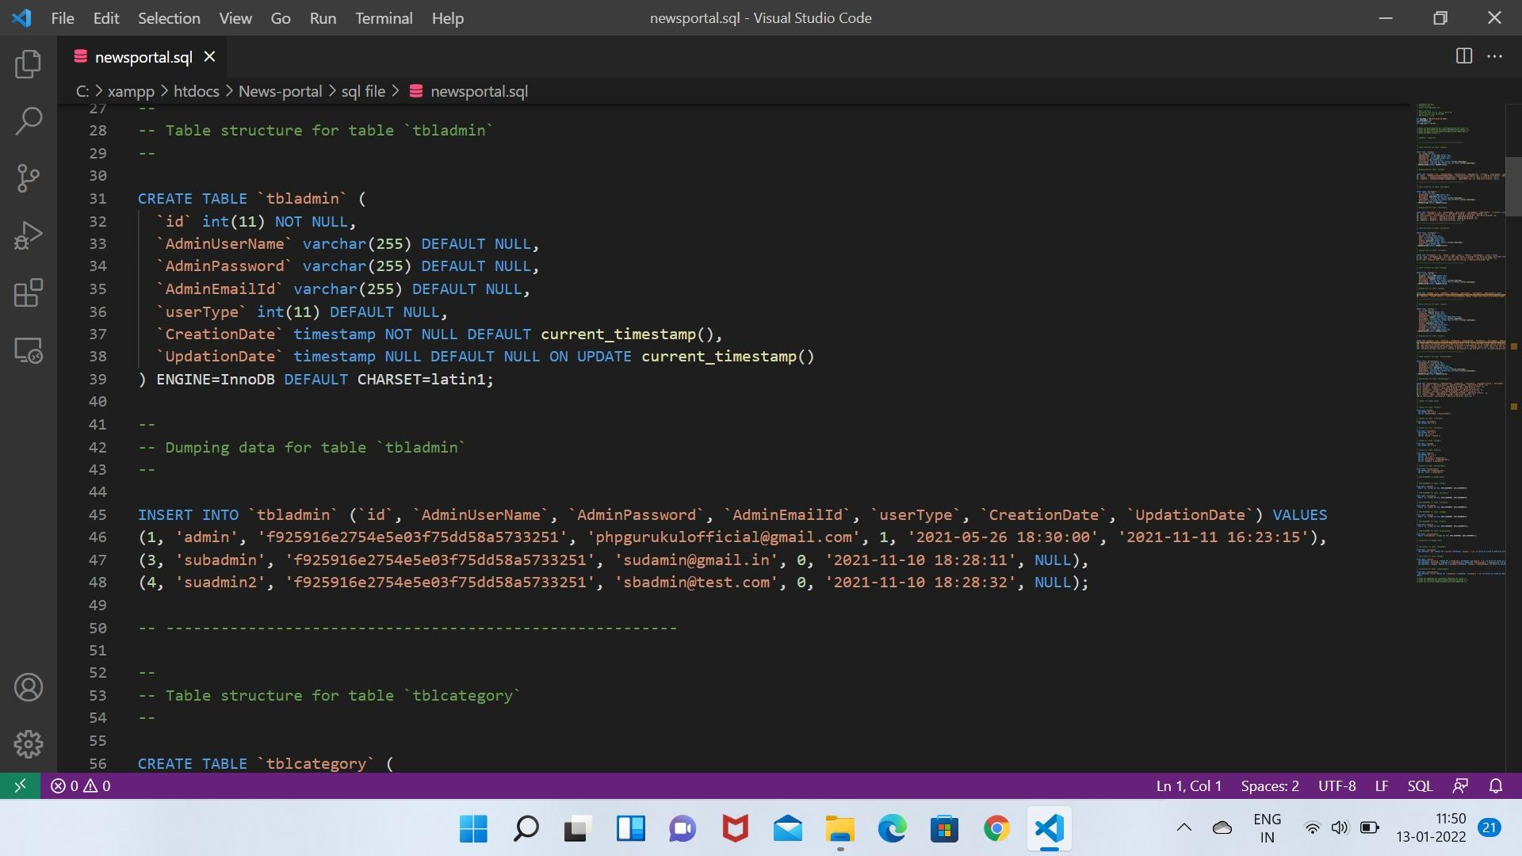

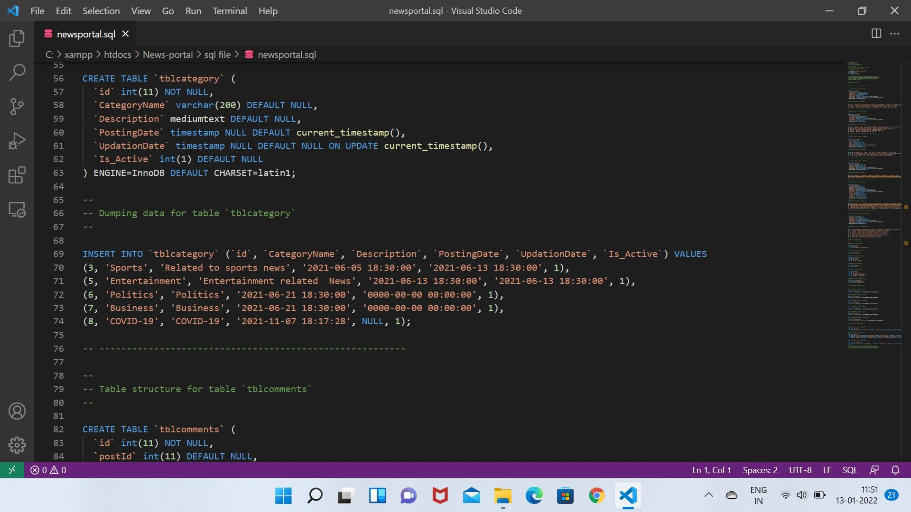

15

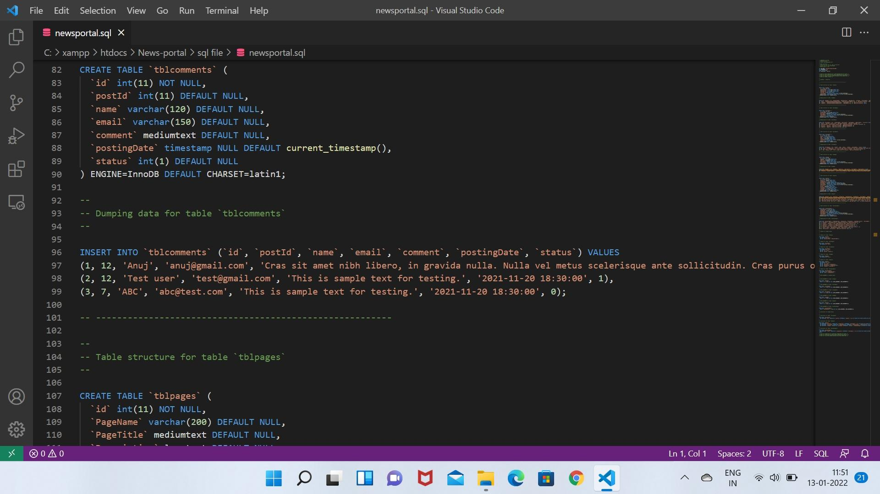

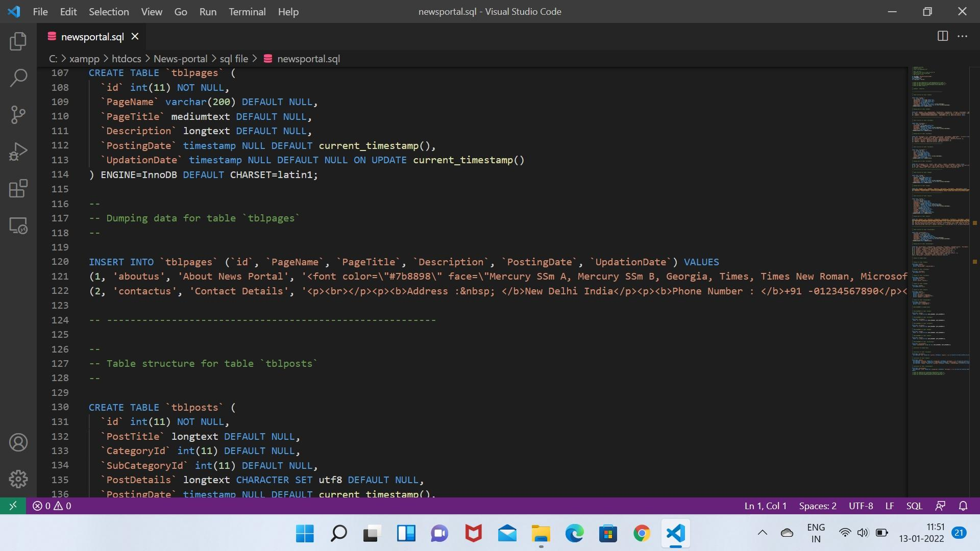

16

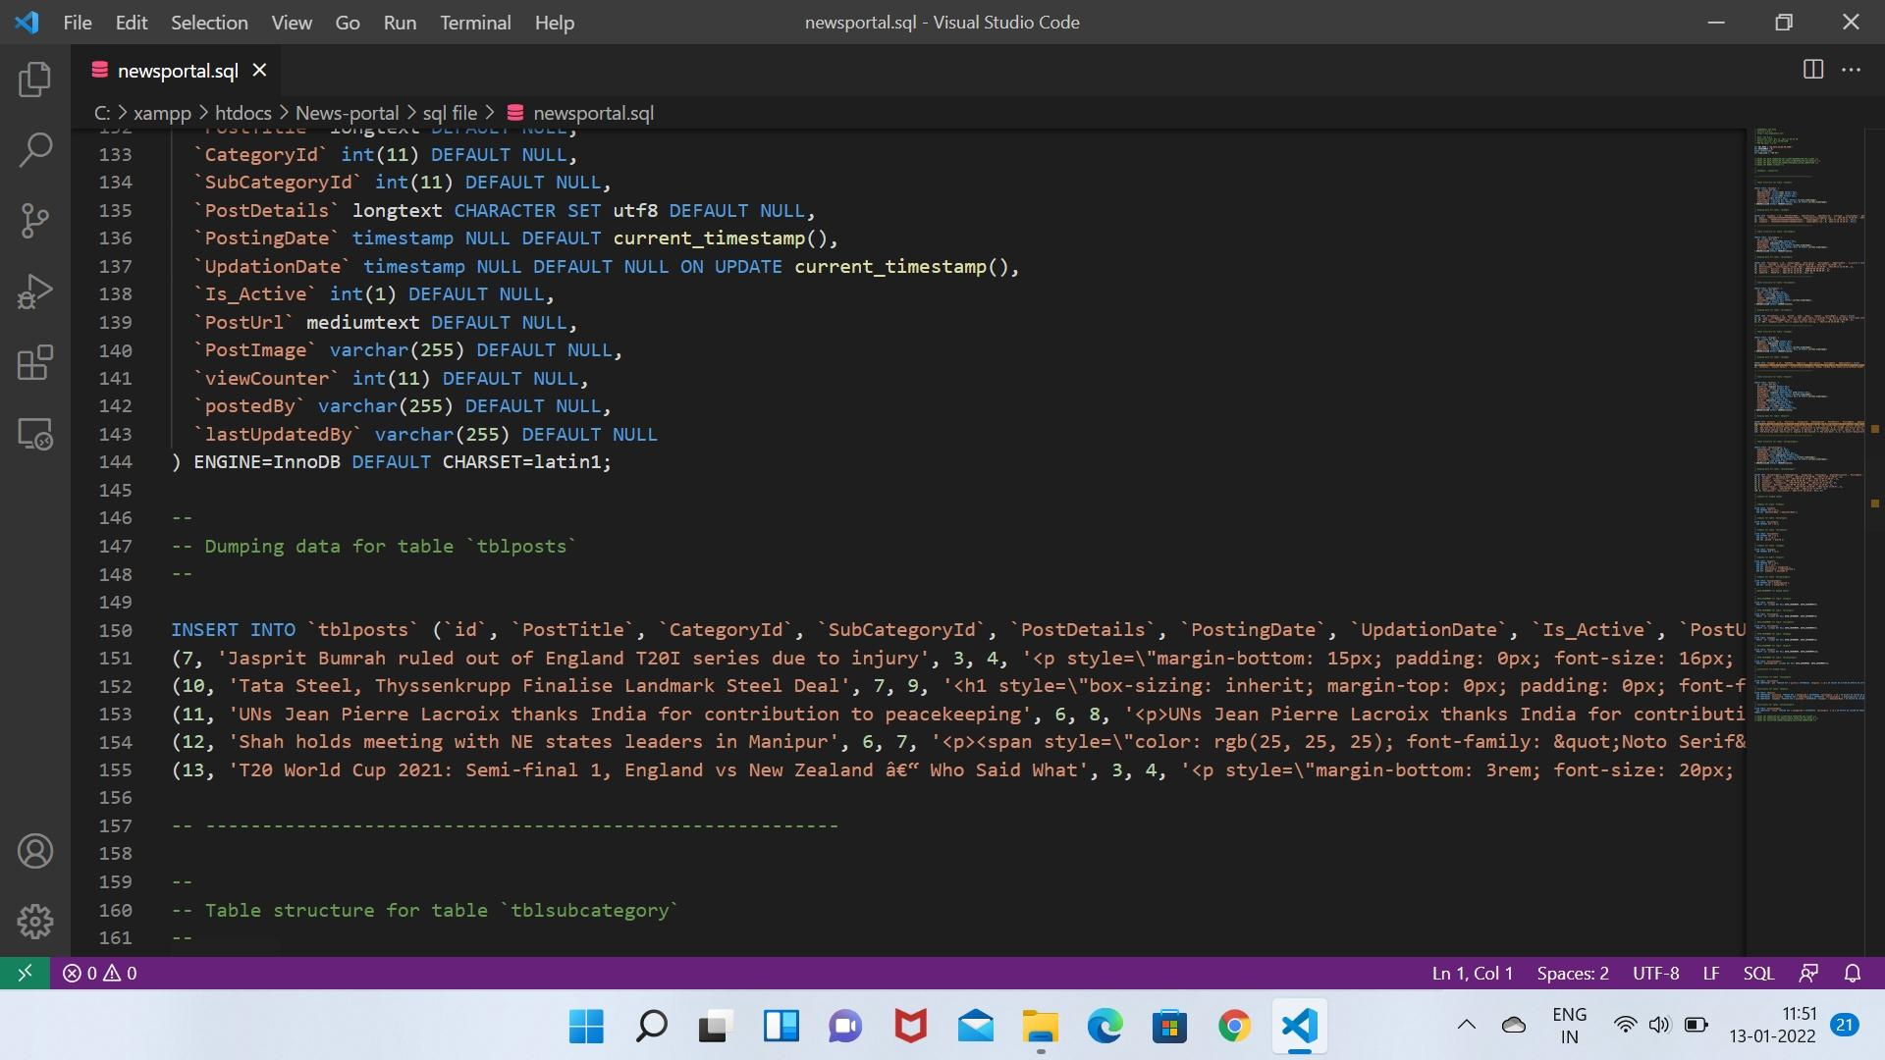

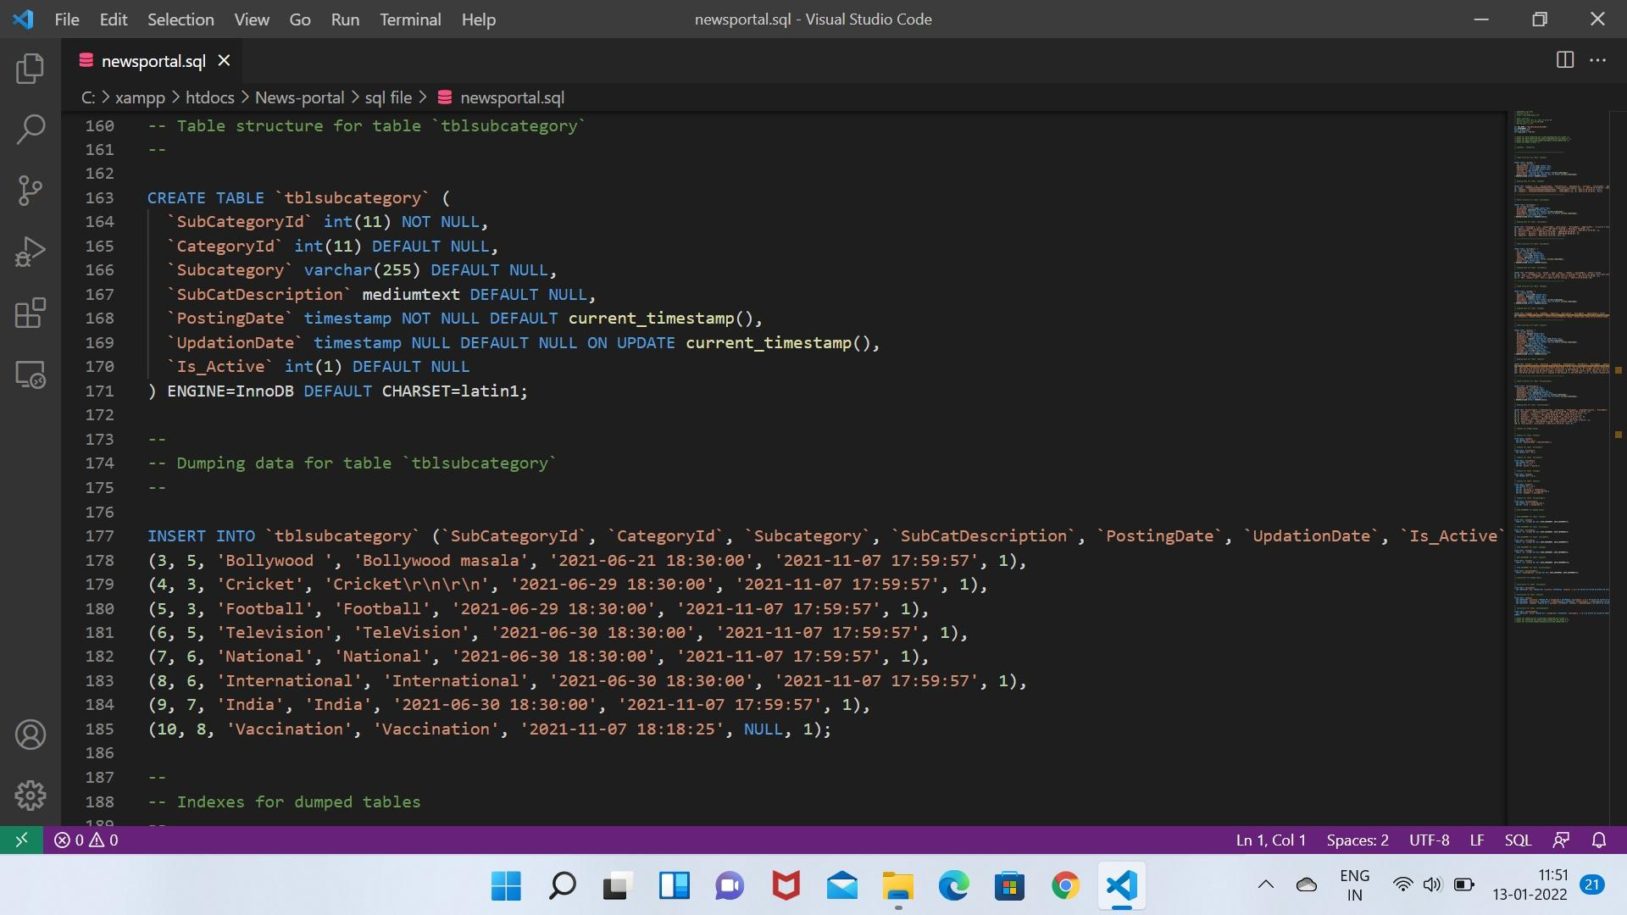

17

**5. OUTPUT SCREENS**

Output Screens of various functionalities in our application are shown over here along with the description.

**HOME PAGE**

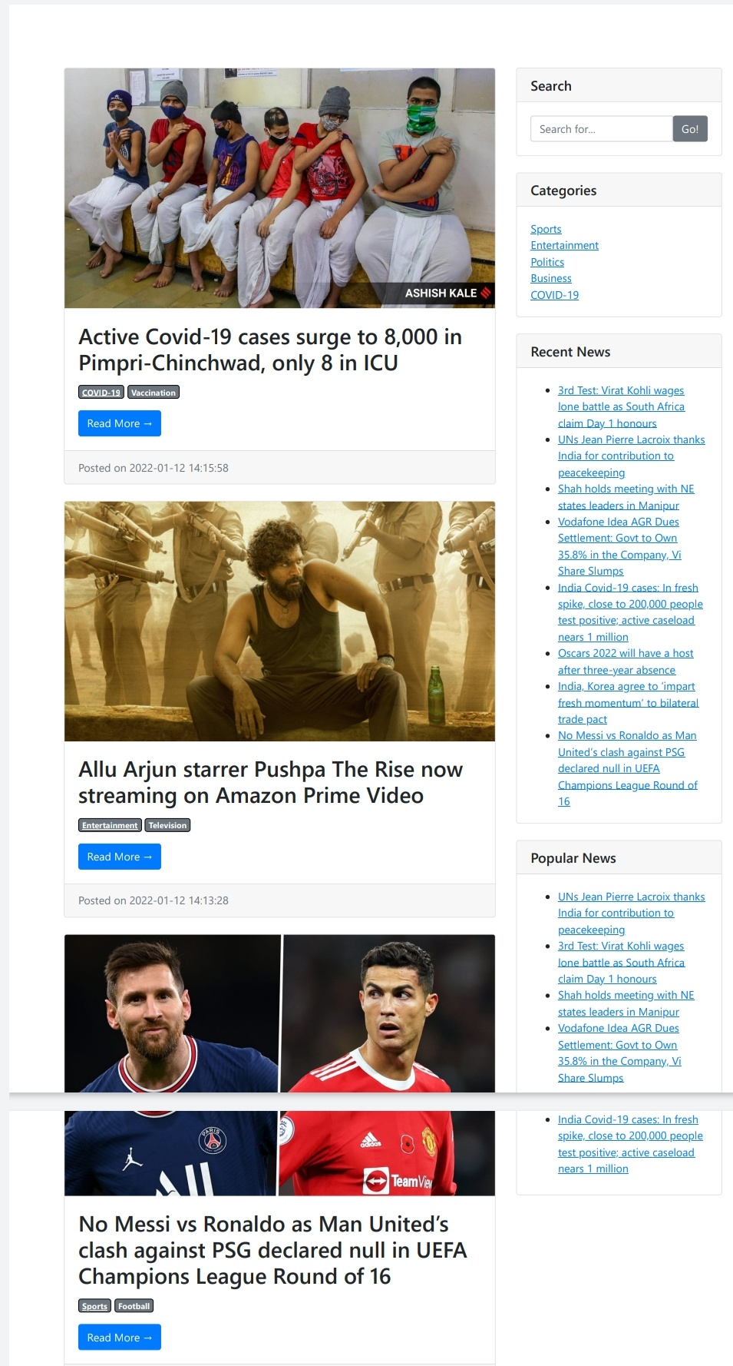

**Fig.Home page**

This is the Home page For Online News Portal System.This page mainly consists of a brief Description of our web-site i.e.; The Online News Portal System. This page has got several tabs named as Home,About us,Administrator,Contact Us..Through home page one can reach to any of the feature he wants to use .About us describes about the what news portal website.Contact Us provides postal address and contact numbers of important persons related to administration in the portal.

18

**About US PAGE:**

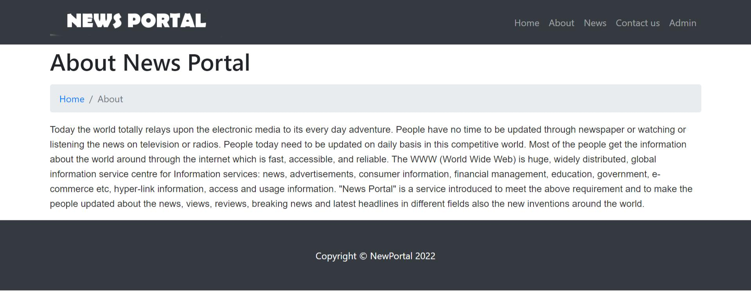

**Fig.about us page**

It displays the overall information about the system about the news portal history, applications, importance and all about the news portal system.

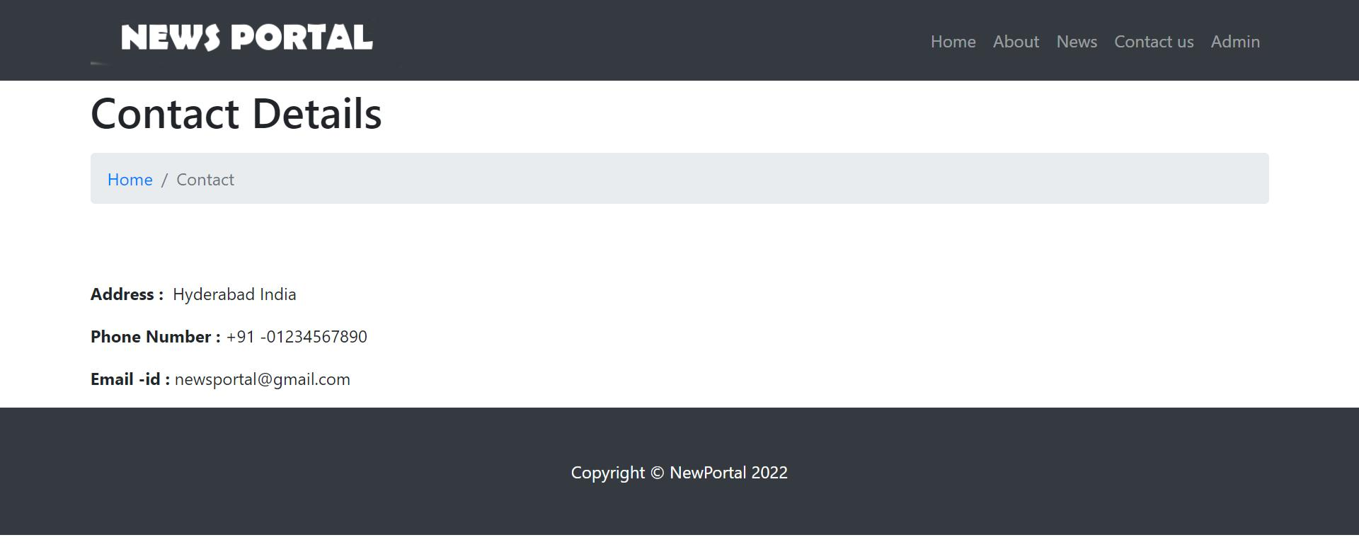**CONTACT US PAGE:**

**Fig.contact us page**

19

If there any quiries or issues in the webiste they provide the details for contacting them.

**CATEGORY NEWS:**

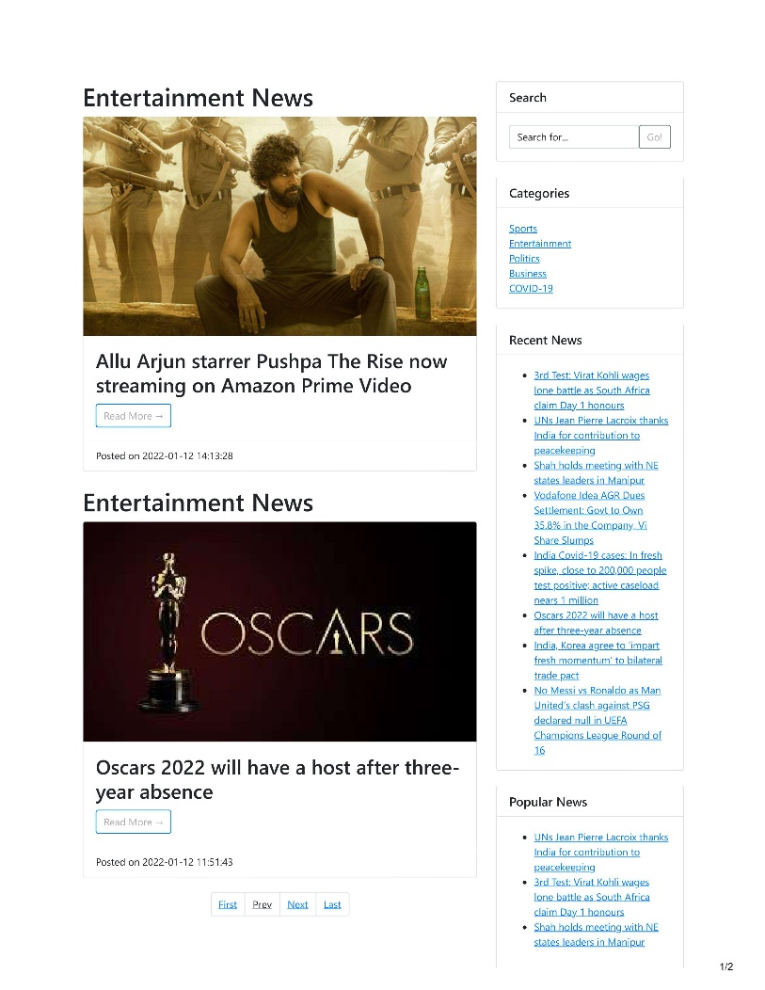The user can use categories to sort and group your post different sections. News under categories like Sports, Entertainment , Politics , Business etc ..

20

**ADMIN LOGIN:-**

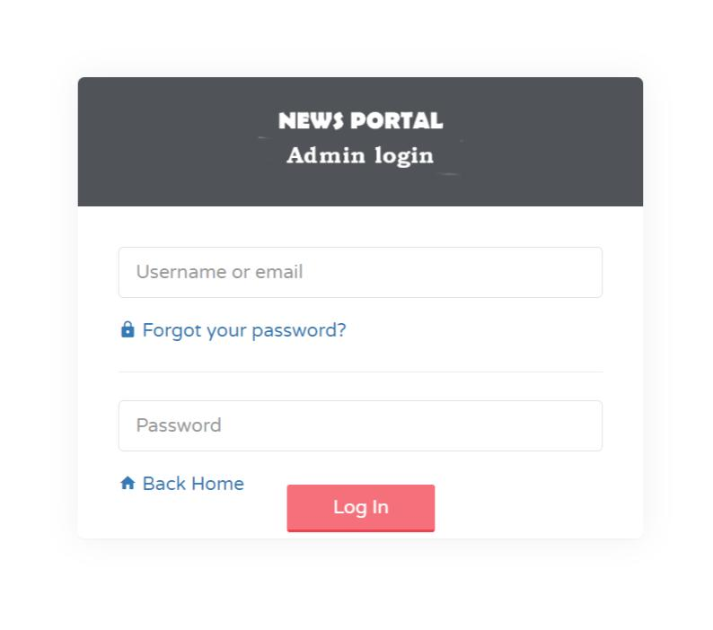 **Fig .admin login**

This is the sign in page of admin where is has the buttons username and password provided for the admin. And then click the sign in button for the registration.

**ADMIN DASHBOARD:-**

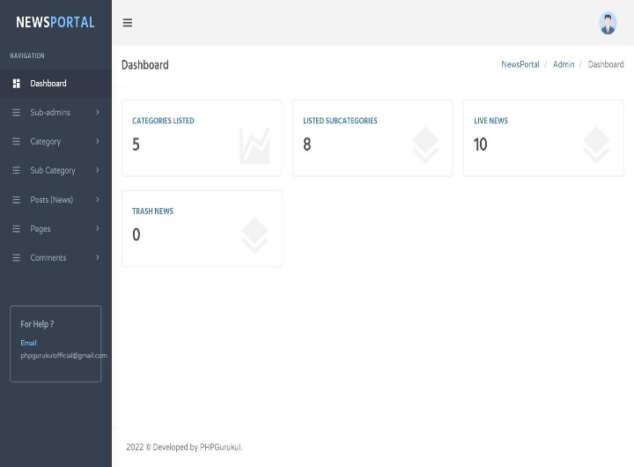

**Fig .admin dashboard**

21

This shows the overall data about the system.

**SUB-ADMIN:-** Sub admins can help with management task on an account, as determined by permissions admins grant them.

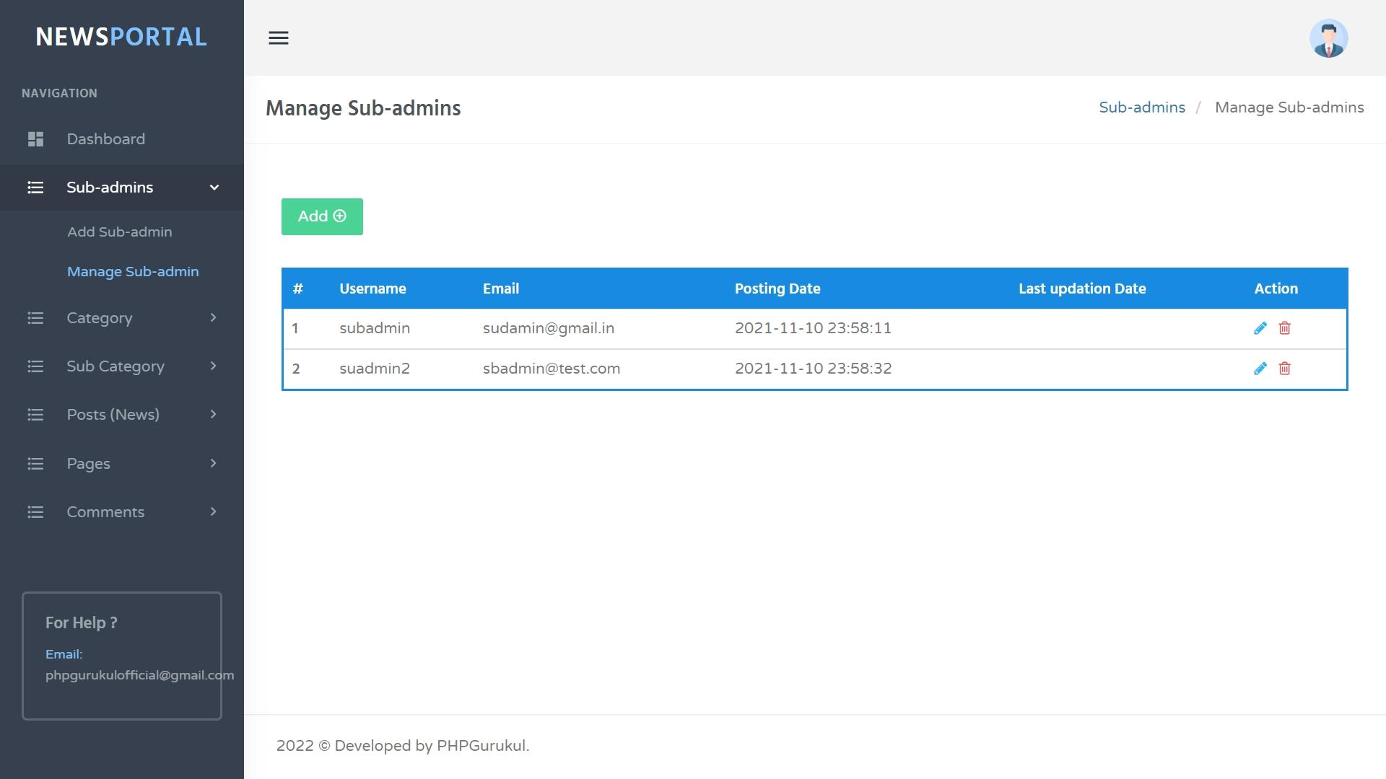

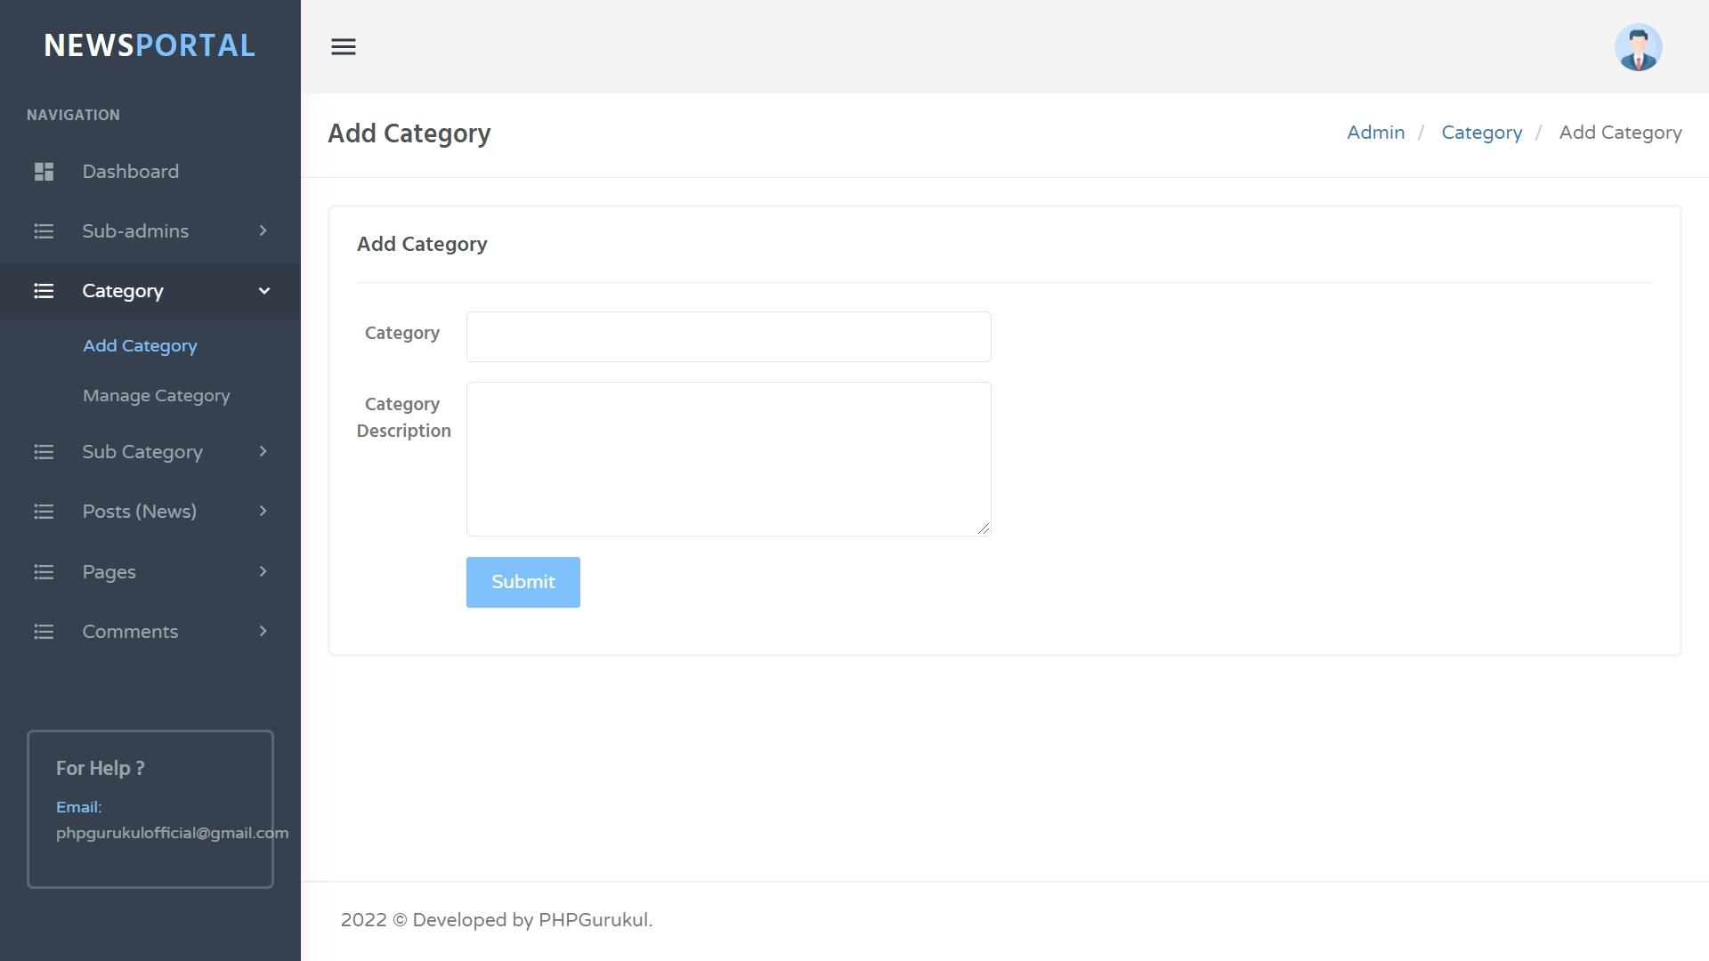 **CATEGORY:** This manages all the categories and the post related to news .

22

**POSTS:** This manages all the posts in news portal

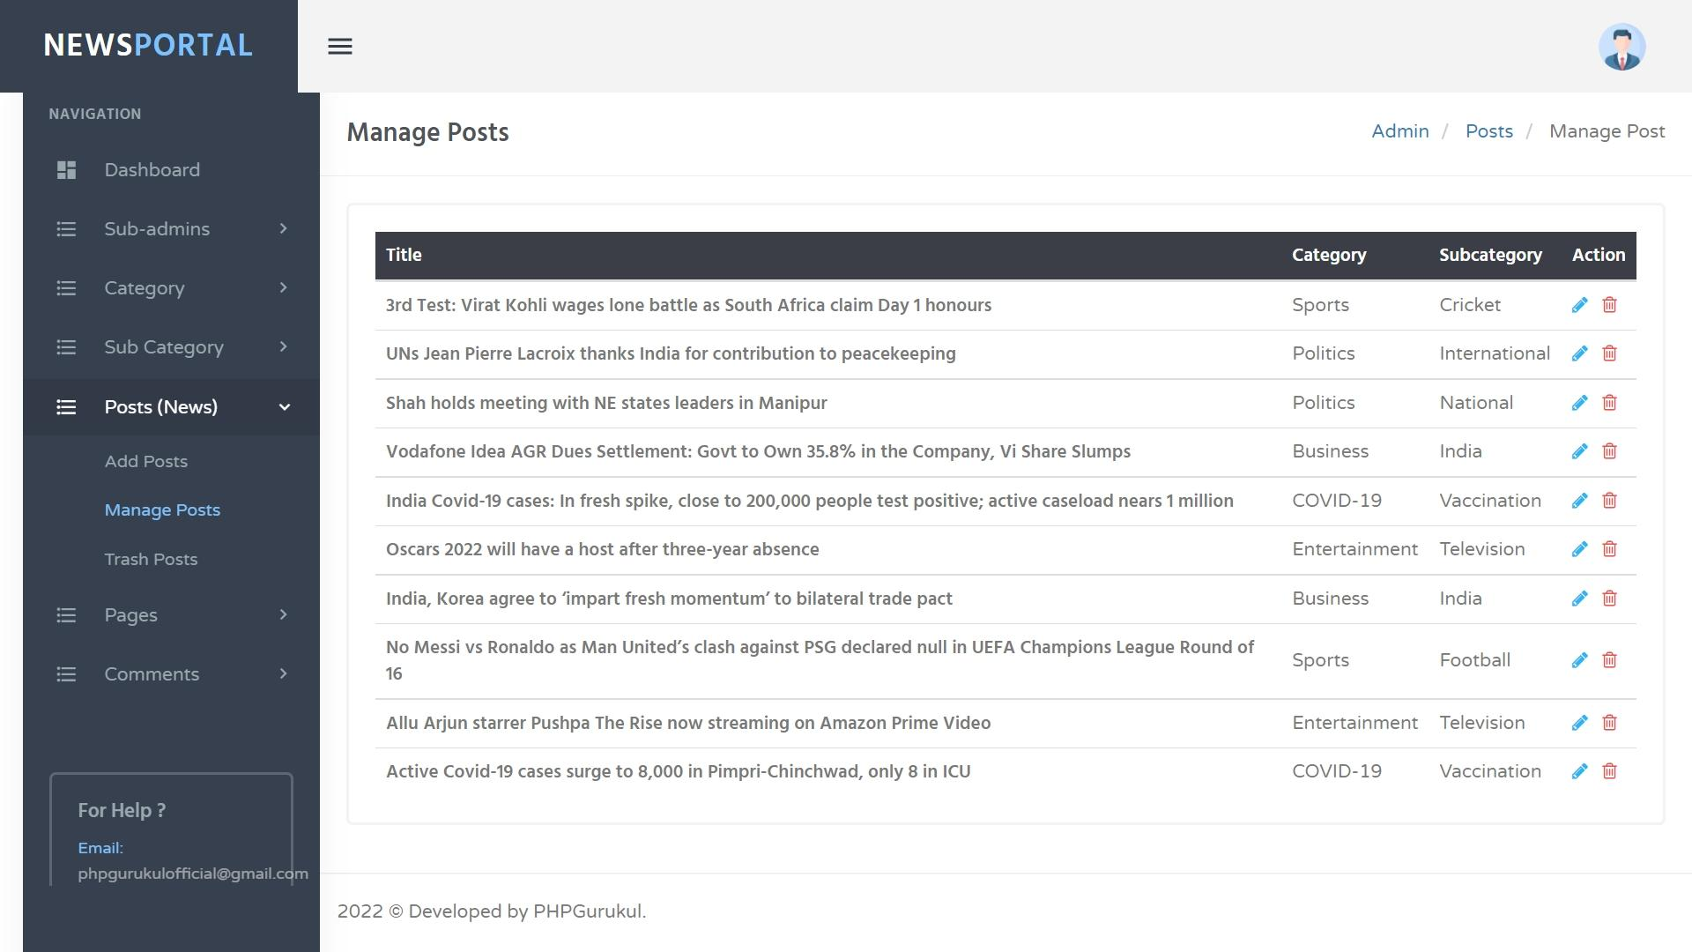

**COMMENTS:**

This manages all the user comments and its approval by the admin.

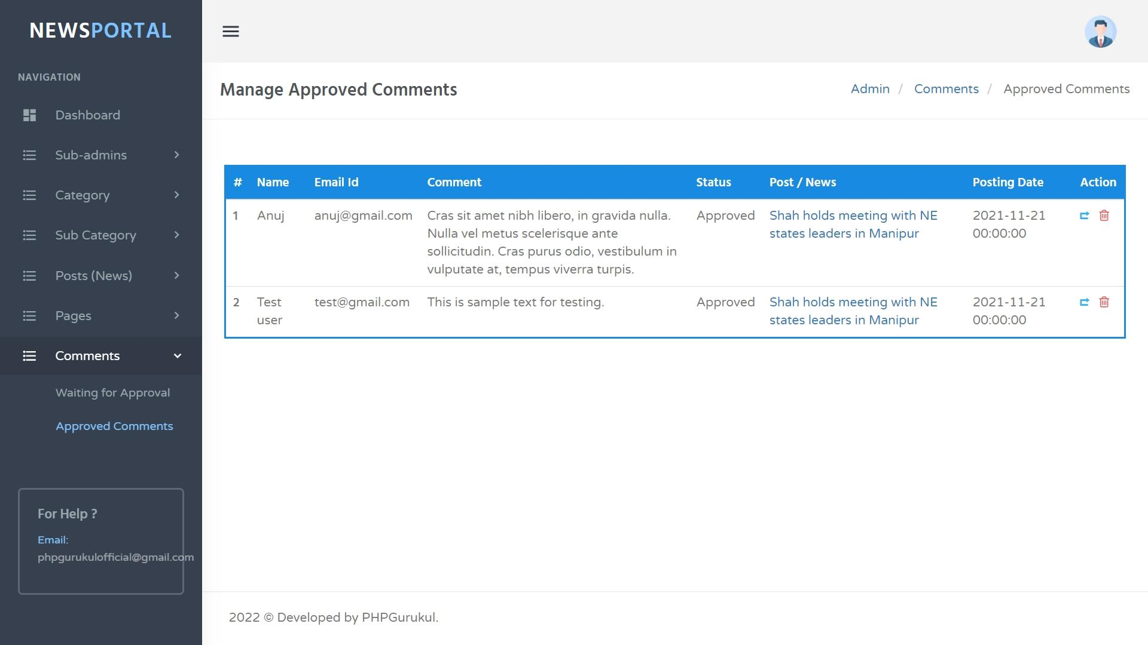

23

**7. CONCLUSION AND FUTURE SCOPE**

**Conclusion**

* In our project work, an attempt has been made to develop News or information based web site.
* We develop this project that helps the people and make them aware so that they can know any news. To establish this website we use various methodologies. To develop this project we have faced many problem but we hardly tried to develop this project. Our supervisor helps us by giving his valuable opinion, decision and time.

**Future Scope**

* The future scope of our project is valuable. It was very difficult to complete project within this time duration. In future if we get chance we will develop this website for large volume.
* As for other future developments, the following can be done:
* We will manage news reporting system.
* We can make video conferencing system.
* We update our database.
* Sensibility level could add be added.

**BIBLIOGRAPHY**

1. Herbert Schildt, *The Complete Reference Java2* Fifth Edition, Tata McGraw-Hill Edition 2002.
2. Grady Booch, James Rumbaugh, Ivar Jacobson. *The Unified Modeling Language User*
   1. *www.w3schools.com*
3. *www.wikipedia.org*

24

**APPENDIX-A: MySQL**

This appendix describes the MySQL programs named in the following list. Later in the appendix, each program is described in more detail, including a description of its purpose, its invocation syntax, the options it supports, and a description of any internal variables it has. (Note that programs are ordered without regard to any '_' or '.' characters in their names.) Unless otherwise indicated, the program options and variables listed here have been present in MySQL at least as far back as MySQL 3.22.0.

**.**libmysqld

The embedded MySQL server. This isn't really a program; it's a library that you link into other programs to produce standalone applications that include a server.

**.**myisamchk and isamchk

Utilities for checking and repairing tables, performing key distribution analysis, and de-activating and re-activating indexes.

.myisampack and pack_isam

Utilities to produce compressed read-only tables.

.mysql

Interactive program with line-editing capabilities for sending queries to the MySQL server; can also be used in batch mode to execute queries stored in a file.

.mysqlaccess

Script for testing access privileges.222

.mysqladmin

Utility for performing administrative operations.

.mysqlbinlog

Utility for displaying binary update logs in ASCII format.

.mysqlbug

Script for generating bug reports.

.mysqlcheck

Table checking, repair, optimization, and analysis utility.

.mysql_config

Utility that displays proper flags for compiling MySQL-based programs.

.mysqld

The MySQL server; this program must be running so that clients have access to the databases administered by the server.

25

.mysqld_multi

Script for starting and stopping multiple servers.

.mysqld_safe

Script for starting up and monitoring the MySQL server. (Prior to MySQL 4, this script is named safe_mysqld.)

.mysqldump

Utility for dumping the contents of database tables.

.mysqlhotcopy

Database backup utility.

.mysqlimport

Utility for bulk loading of data into tables.

.mysql_install_db

Script for initializing the server's data directory and grant tables.

.mysql.server

Script for starting up and shutting down the MySQL server.

.mysqlshow

Utility that provides information about databases or tables.

In the syntax descriptions, optional information is indicated by square brackets ([]).

26

**APPENDIX-B:UNIFIED MODELING LANGUAGE**

The Unified Modeling Language (UML) is a general-purpose visual modeling language that is used to specify, visualize, construct, and document the artifacts of a software system. It captures decisions and understanding about systems that must be constructed. It is used to understand, design, browse, configure, maintain, and control information about such systems. It is intended for use with all development methods, lifecycle stages, application domains, and media. The modeling language is intended to unify past experience about modeling techniques and to incorporate current software best practices into a standard approach. UML includes semantic concepts, notation, and guidelines. It has static, dynamic, environmental, and organizational parts. It is intended to be supported by interactive visual modeling tools that have code generators and report writers. The UML specification does not define a standard process but is intended to be useful with an iterative development process. It is intended to support most existing object oriented development processes.

The UML captures information about the static structure and dynamic behavior of a system. A system is modeled as a collection of discrete objects that interact to perform work that ultimately benefits an outside user. The static structure defines the kinds of objects important to a system and to its implementation, as well as the relationships among the objects. The dynamic behavior defines the history of objects over time and the communications among objects to accomplish goals.

Modeling a system from several separate but related viewpoints permits it to be understood for different purposes.

The UML also contains organizational constructs for arranging models into packages that permit software teams to partition large systems into workable pieces, to understand and control dependencies among the packages, and to manage the versioning of model units in a complex development environment. It contains constructs for representing implementation decisions and for organizing run-time elements into components.

UML is not a programming language. Tools can provide code generators from UML into a variety of programming languages, as well as construct reverseengineered models from existing programs. The UML is

27

not a highly formal language intended for theorem proving. There are a number of such languages, but they are not easy to understand or to use for most purposes. The UML is a general-purpose modeling language. For specialized domains, such as GUI layout, VLSI circuit design, or rule-based artificial intelligence, a more specialized tool with a special language might be appropriate. UML is a discrete modeling language.

It is not intended to model continuous systems such as those found in engineering and physics. UML is intended to be a universal general-purpose modeling language for discrete systems such as those made of software, firmware, or digital logic.



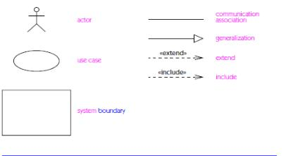

28

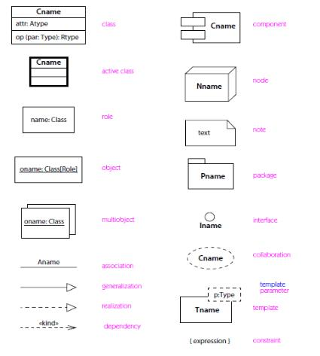

29

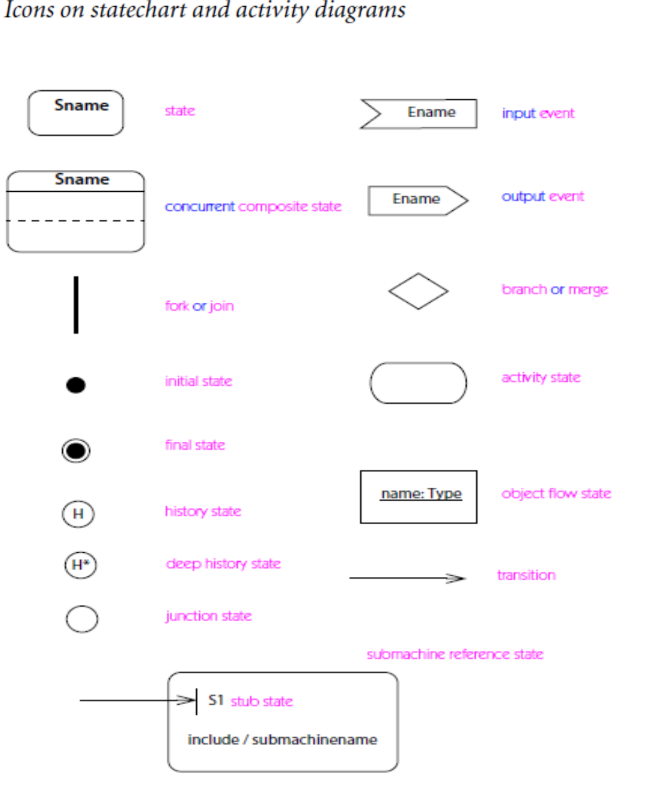

30

**ABSTRACT**

Most of the people in this world like to travel from one place to another no matterwhether it is a small or large distance. The need for a tourism management system that can managetourism information with ease is sought after by every tour management company. TourManagement system is a dynamic website for tourism business. This travel and tourismapplication is designed for travel agencies by which they can manage different tour packages based on the destinations. By using this, the tour company can tailor tour packages spanning various destinations at almost every price point. The also implemented search module allows the administrator to find and update or upgrade the tour packages with ease. This module can also even be extended to a customer application page by whichcustomers can find the right tour package for them at every budget, depending on the tour locations. The main purpose is to help tourism companies to manage tour packages . Thesystem can also be used for both professional and business trips. The proposed systemmaintains a centralized repository to make necessary travel arrangements and to retrieve information easily.

|  |  |  |
| --- | --- | --- |
| **Team No: 05** |  |  |
|  |  | **Title** |
| **Roll No** | **Name** |  |
|  |  |  |
| 18311A05R4 | Ch.Udhay | Online News Portal System |
|  |  |  |
| 18311A05V2 | N.Satish Kumar |  |
|  |  |  |
|  | | |

|  |  |  |  |
| --- | --- | --- | --- |
| **Student 1** | **Ch.Udhay** | **Project Coordinator** | **HOD** |
| **Student 2** | **N.Satish Kumar** | **Ms N.Shivani** | **Dr.Aruna Varanasi** |
|  |  | **Assistant professor** | **Department of CSE** |

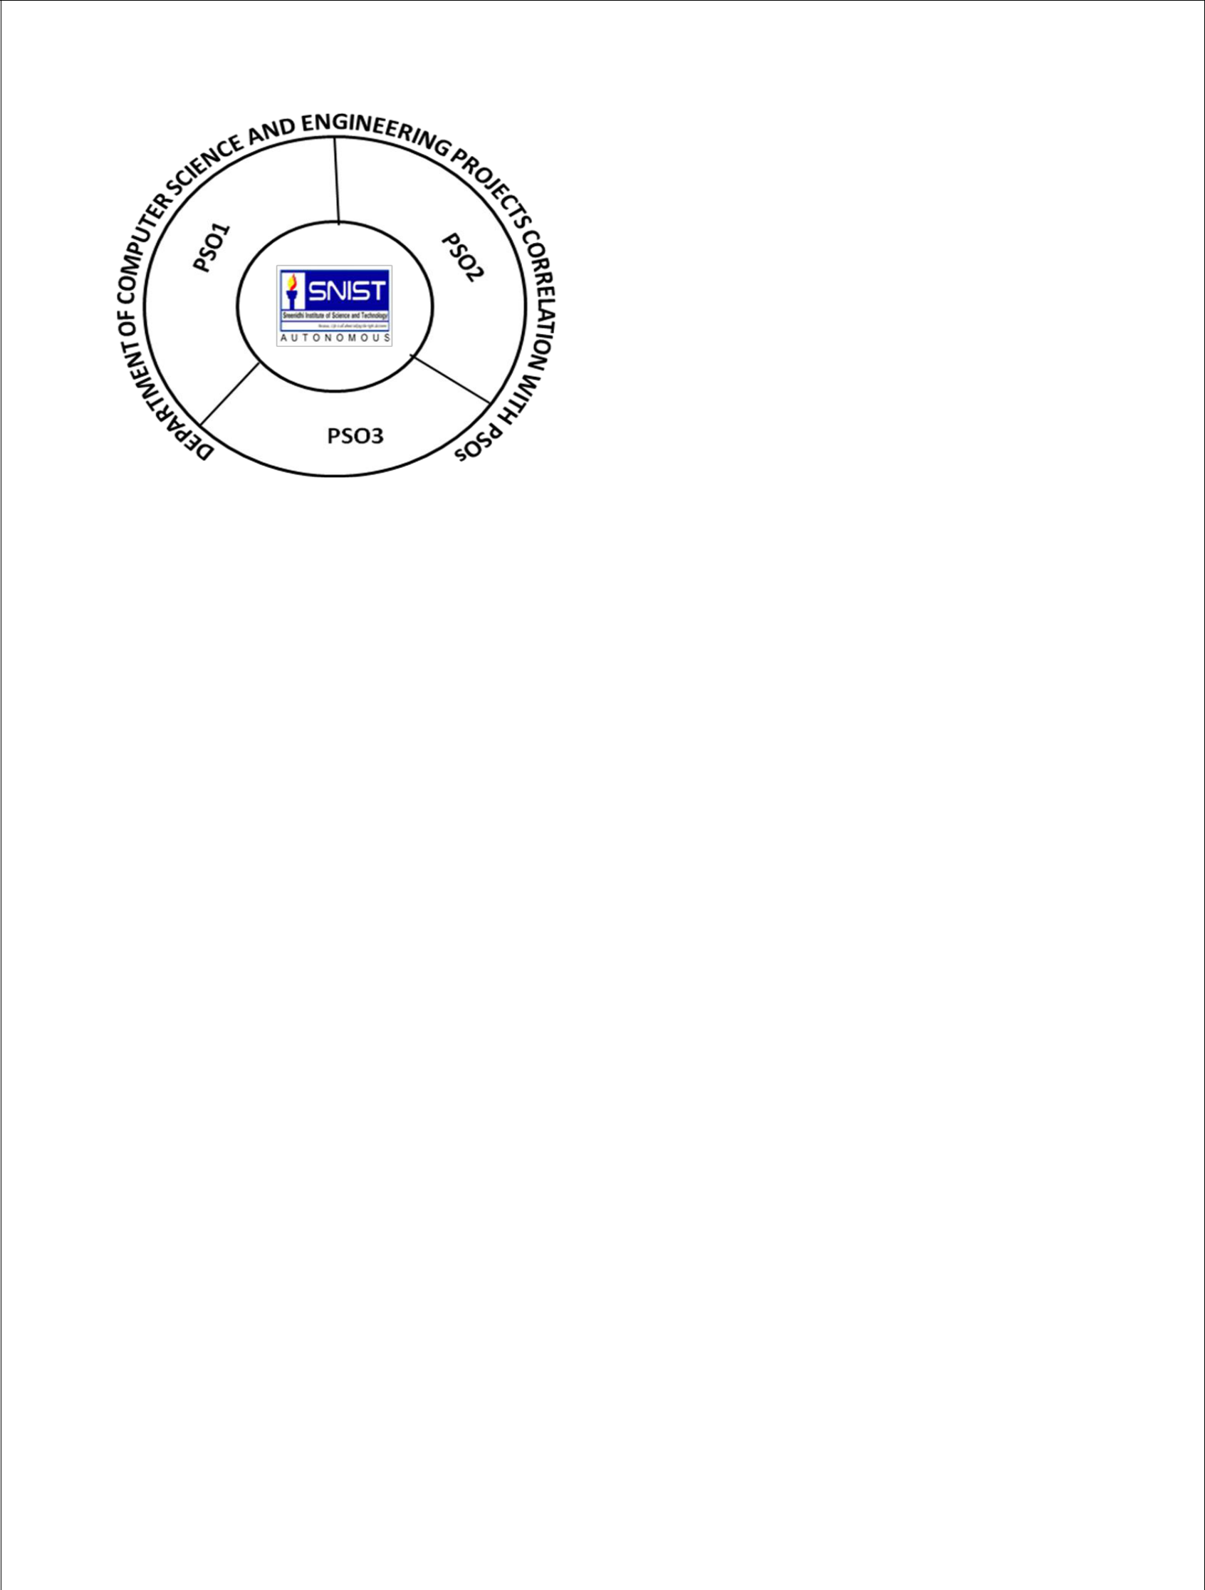

**H** **High**

**M** **Moderate**

**L** **Low**



**SREENIDHI INSTITUTE OF SCIENCE AND TECHNOLOGY DEPARTMENT OF COMPUTER SCIENCE AND ENGINEERING Projects Correlation with POs**

|  |  |  |  |  |  |  |  |  |  |  |  |  |
| --- | --- | --- | --- | --- | --- | --- | --- | --- | --- | --- | --- | --- |
| **PO1** | **PO2** | **PO3** | **PO4** | **PO5** |  | **PO6** | **PO7** | **PO8** | **PO9** | **PO10** | **PO11** | **PO12** |
|  |  |  |  |  |  |  |  |  |  |  |  |  |
| **H** | **M** | **H** | **M** | **M** | **L** |  | **H** | **M** | **H** | **H** | **L** | **H** |
|  |  |  |  |  |  |  |  |  |  |  |  |  |

**Project Coordinator**

**HOD**

**Ms.N.Shivani**

**Dr.Aruna Varanasi**

**Assistant professor**

**Department of CSE**

|  |  |  |  |  |  |  |  |  |  |  |  |  |  |  |  |  |  |  |  |  |
| --- | --- | --- | --- | --- | --- | --- | --- | --- | --- | --- | --- | --- | --- | --- | --- | --- | --- | --- | --- | --- |
| **Team No: 05** | | | | |  | | | | | | |  | | | | | | | | |
|  | | | | |  | | | | | | | **Title** | | | | | | | | |
| **Roll No** | | | | | **Name** | | | | | | |  | | | | | | | | |
|  | | | | |  | | | | | | |  | | | | | | | | |
| 18311A05R4 | | | | | Ch.Udhay | | | | | | | Online News Portal System | | | | | | | | |
|  | | | | |  | | | | | | |  | | | | | | | | |
| 18311A05V2 | | | | | N.Satish Kumar | | | | | | |  | | | | | | | | |
|  | | | | |  | | | | | | |  | | | | | | | | |
|  |  |  | |  | |  |  | |  | |  | | |  |  |  | | |  |  | |  |  |
|  |  | **Batch No.** | |  | |  | **Roll No.** | |  | | **Product** | | |  |  | **Application** | | |  | **Research** | |  |  |
|  |  |  |  |  | | | | |  | |  | |  |  |  |  |  |  |  |  | |  |  |
|  |  |  |  | 18311A05R4 | | | | |  |  |  | |  |  |  | **✓** | |  |  |  | |  |  |
|  |  |  | |  | |  | | |  | |  | |  |  |  |  |  |  | |  |  |
|  |  | **05** | | 18311A05V2 | | | | |  |  |  | |  |  |  |  |  |  | |  |  |
|  |  |  |  |  | |  | |  |  |  |  |  |  |  |  | |  |  |
|  |  |  |  |  | |  |  |  |  |  |  | |  |  |  |  |  |  |  |  | |  |  |
|  |  |  |  |  | |  | **ARTIFICIAL** | | |  | **COMPUTER** | | | |  |  |  |  |  |  | |  |  |
|  |  |  |  |  | |  |  | **NETWORKS,** | | | |  | **DATA** |  |  |  |  | |  |  |
|  |  |  |  |  | |  | **INTELLIGENCE,** | | |  |  |  |  |  |  | |  |  |
|  |  |  |  |  | |  |  | **INFORMATI** | | | | **WAREHOUSING,** | |  |  |  |  | | **INTERN** | |
|  |  |  |  |  | |  |  | **MACHINE** | |  |  | **CLOUD** | | **SOFTWARE** | |
| **Batc** | |  |  |  | |  |  |  | **ON** | | |  | **DATA MINING,** | |  |  | **ET OF** |
|  | **Roll No.** | | |  | **LEARNING AND** | | |  |  |  | **COMPUTING** | | **ENGINEERING** | |  |
|  |  |  | **SECURITY,** | | | |  | **BIG DATA** |  | **THINGS** | |
| **h No.** | |  |  |  | **DEEP** | |  |  |  |  |  |  | |
|  |  |  | |  |  |  | **CYBER** | | |  | **ANALYTICS** | |  |  |  |  | |  |  |
|  |  |  |  |  | |  |  | **LEARNING** | |  |  |  |  |  |  | |  |  |
|  |  |  |  |  | |  |  |  | **SECURITY** | | | |  |  |  |  |  |  | |  |  |
|  |  |  |  |  | |  |  |  |  |  |  |  |  |  |  |  | |  |  |
|  |  |  |  |  | |  |  |  |  |  |  | |  |  |  |  |  |  |  |  | |  |  |
| 05 |  |  | 18311A05R4 | | |  |  |  |  |  |  | |  |  |  |  |  |  |  | **✓** | |  |  |
|  |  |  |  | |  |  |  |  |  |  | |  |  |  |  |  |  |  |  |  |
|  |  |  |  |  | |  |  |  |  |  |  | |  |  |  |  |  |  |  |  |  |
|  |  |  | 18311A05V2 | | |  |  |  |  |  |  | |  |  |  |  |  |  |  |  |  |
|  |  |  |  |  |  |  |  |  | |  |  |  |  |  |  |  |  | |  |  |
|  |  |  |  |  |  |  |  |  | |  |  |  |  |  |  |  |  | |  |  |
|  |  |  |  |  |  |  |  |  | |  |  |  |  |  |  |  |  | |  |  |



**Project Coordinator**

**HOD**

**Ms.N.Shivani**

**Dr.Aruna Varanasi**

**Assistant professor**

**Department of CSE**